better-ball.d.txt

point light position: -2, 0, 5

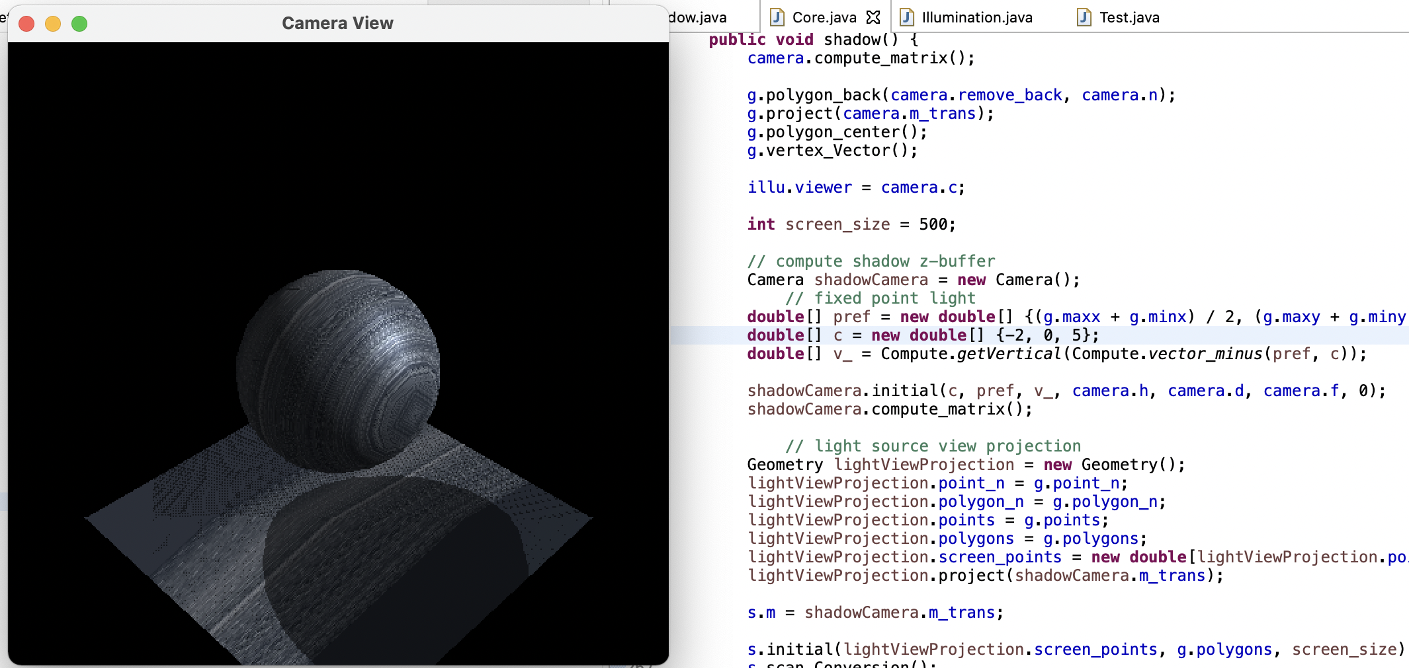

point light position: 3, 3, 3

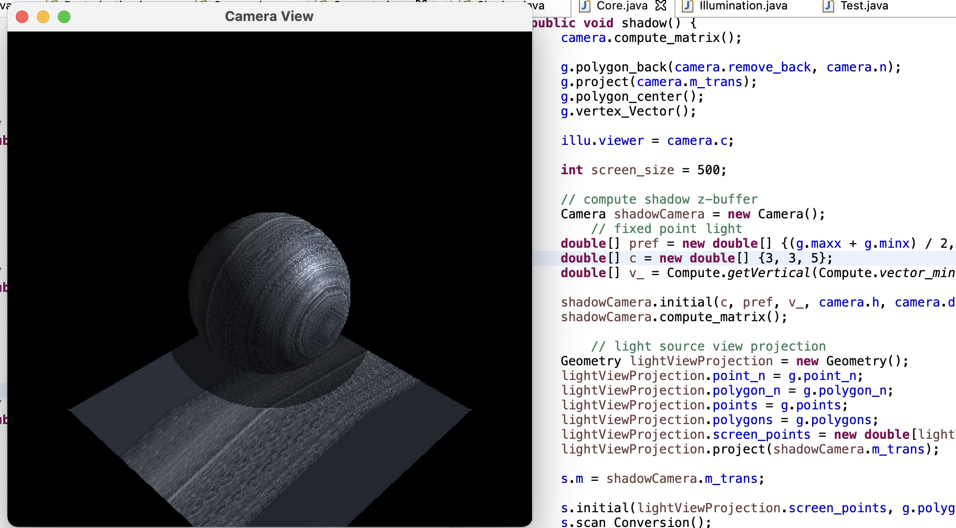

point light position: 0, 0, 5

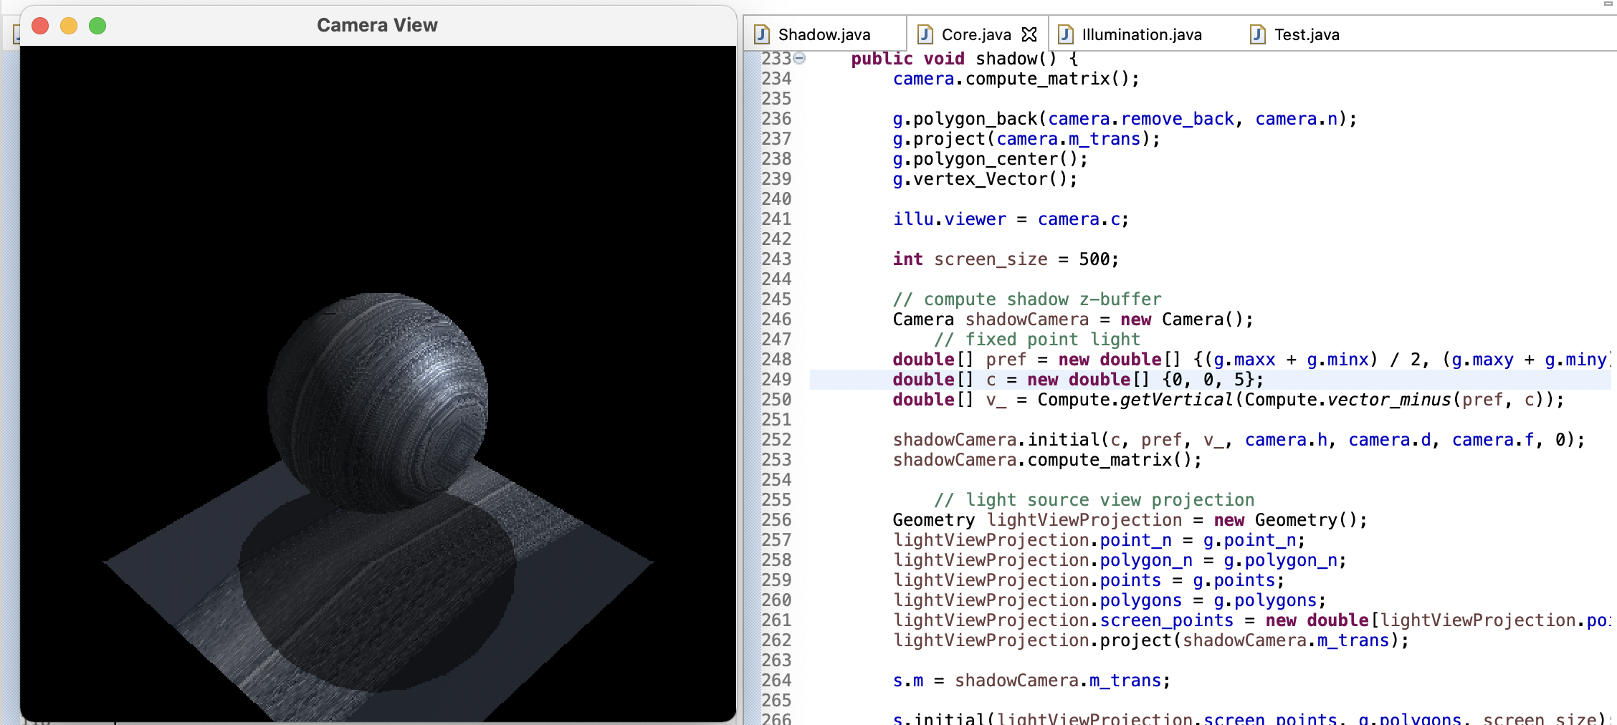

bench.d.txt

point light position: 3, 3, 3

